KUI WRITTEN REPORT – SELECTION OF OPTIMAL METHOD

TASK 1:

The classifier 1 has 50 α-parameters and 100 data points each which when tested for each one in comparison to the GT.dsv file within the same directory using the false negative, false positive and correct ratios. I notice that it has for α-parameters (22, 23, 24) we have a 97% accuracy a false positive rate of 2% and false positive rate of 4% and a true positive rate of 96% so for any of these alpha parameters we can see a very high accuracy with minimized errors and so should be the best classifier

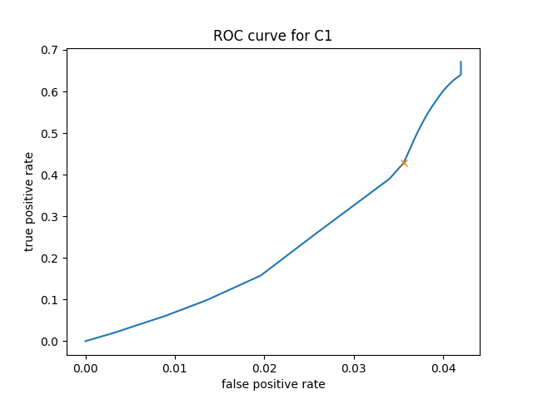

TASK 2:

For the best classifier, I will pick the classifier C1 and the parameter 22(or 23 or 24). This is because as described earlier there is a very small percentage of false negatives(0.04) and false positives(0.02) as well as a very high percentage of true positives(0.96) and true negatives(0.98). Hence, since they are very sensitive, top secret and must be kept with the utmost safety. This algorithm has the best accuracy and make very minimal amount of errors so it should be the best.

TASK 3:

For the safety-first task, I would write the function in such a way that I have the previous best classifier accuracy score, true positive rate, false negative rate and false positive score. Then, I would check through each α-parameter and pick the best classifier based on the highest accuracy score, highest true positive, lowest false negative and lowest false positive, I would go on to compare these values with the previous and if the classifier accuracy score is greater than the previous best classifier accuracy score, classifier true positive rate is greater than the previous best classifier true positive rate, classifier false negative rate is less than the previous best classifier false negative rate and classifier false positive rate is less than the previous best classifier false positive rate. (Python function attached)